Assignment 5: User assign to new create table

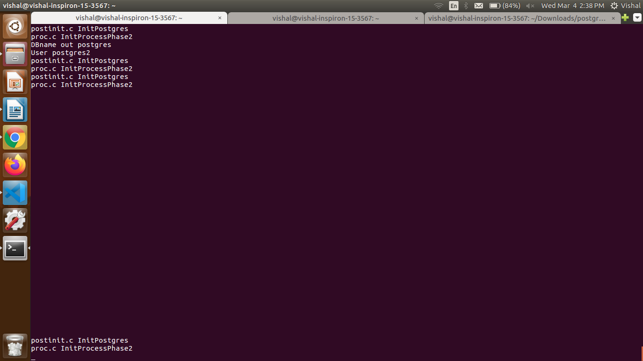
Execution flow:

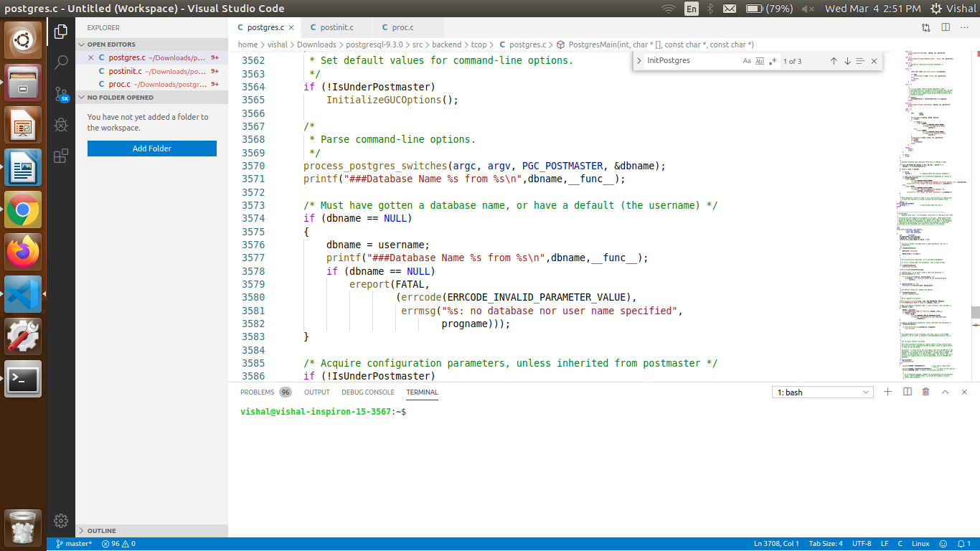

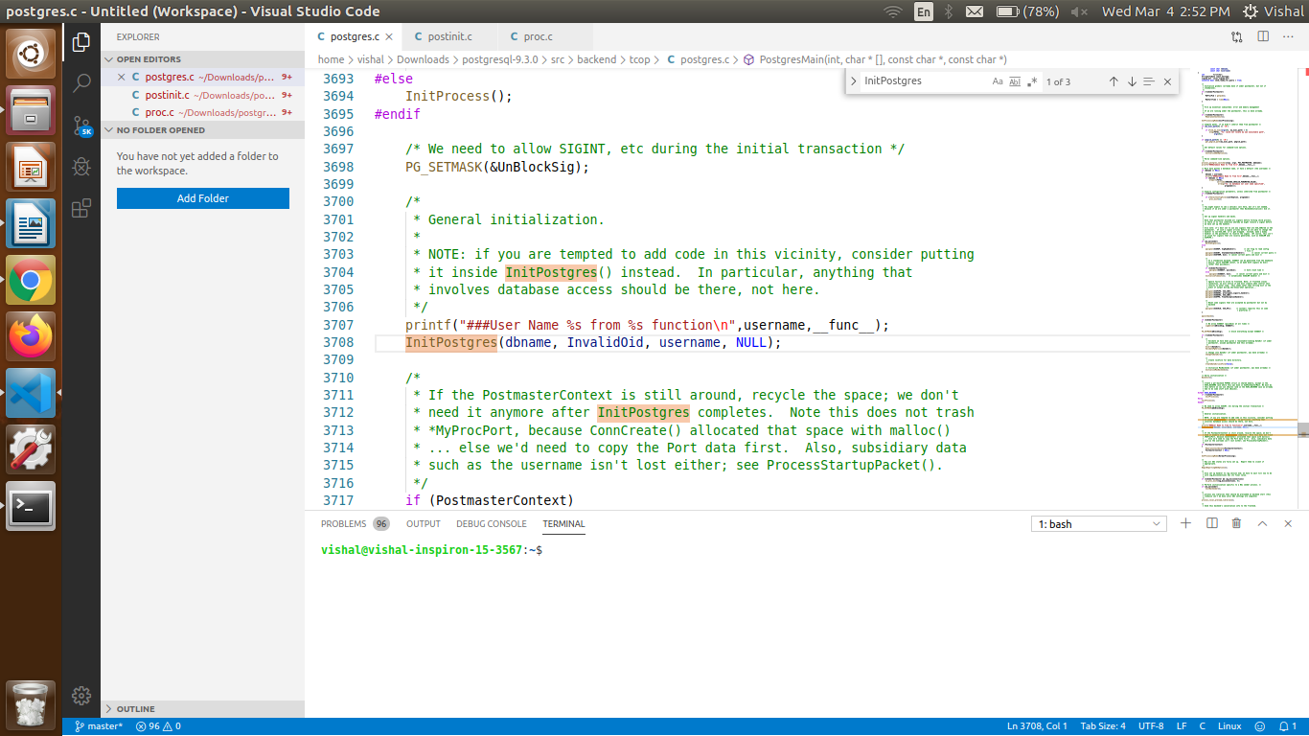

First it will initlialise postgres to use from initpostges function from postinit.c file

After login to postgres it capture user name and database name
and display
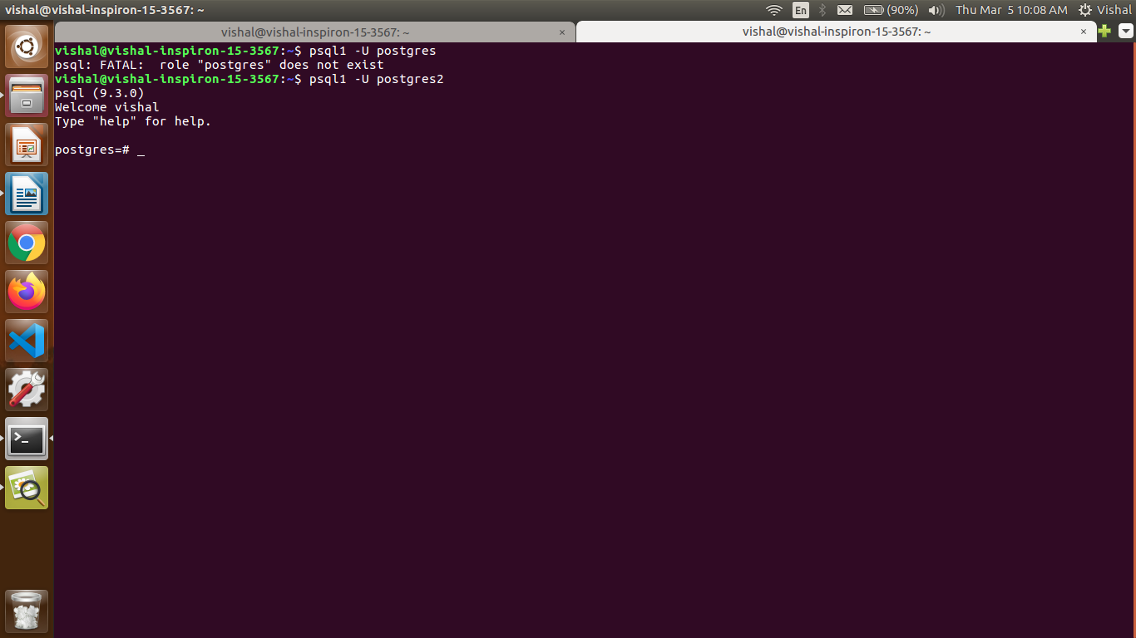
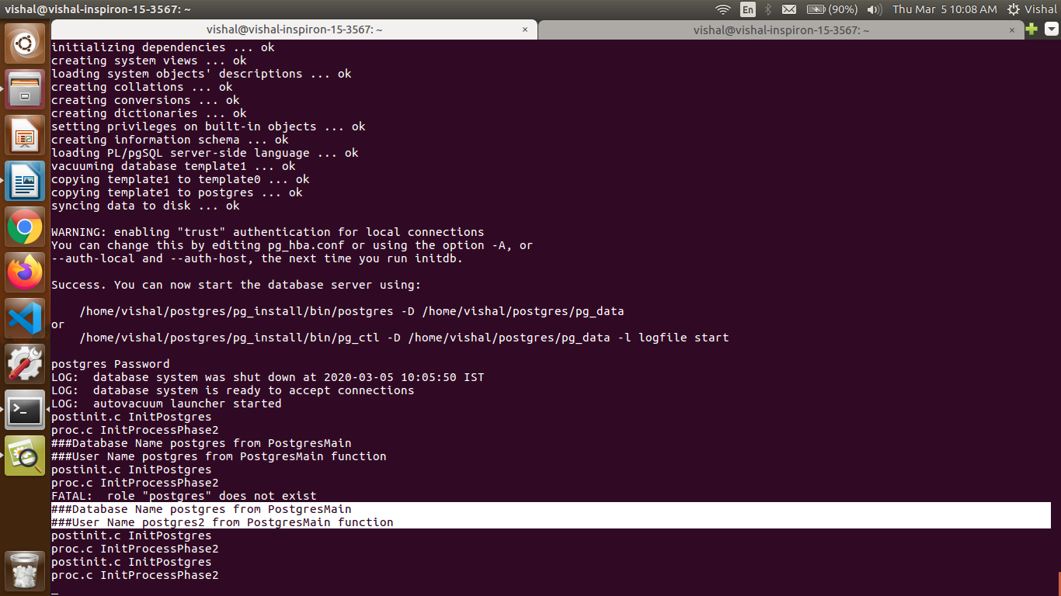
When we fire create table command
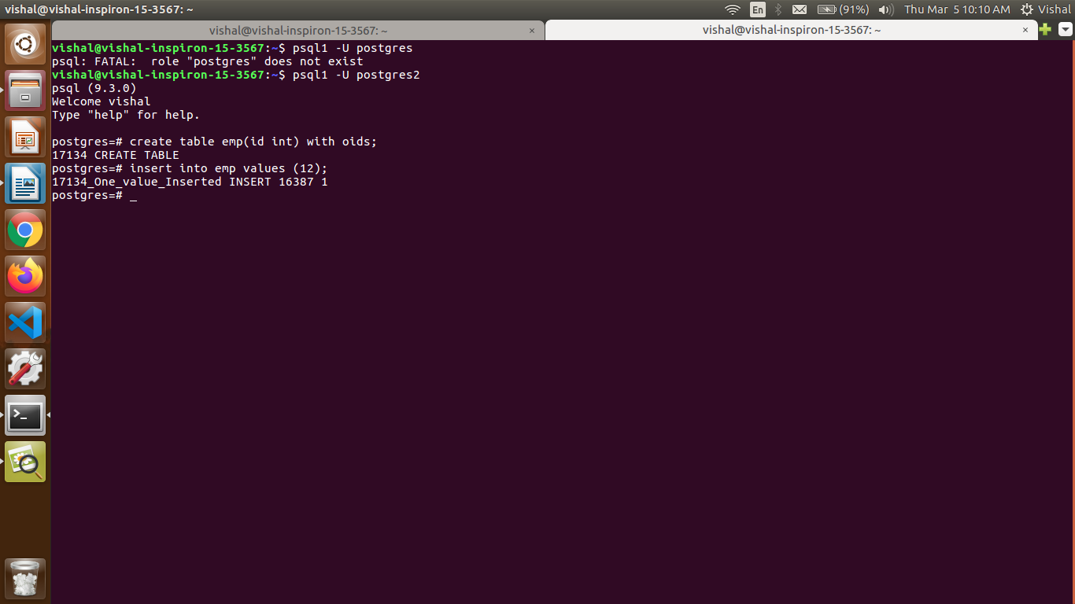

WorkFlow:
1.proc.c InitProcessPhase2
2.[postgres.c ->PostgresMain function.] calls[ utility.c->CreateCommandTag function.] calls[ postgres.c -> exec_simple_query function]calls [postgres.c-> PostgresMain function.]calls[utility.c ->CreateCommandTag function]calls[postgres.c ->exec_simple_query function] and execute create table command and assign username already stored in username variable from PostgresMain function in postgres.c.
